**Dive into Nostalgia: Best Platforms to Watch Anime and Cartoons**

Nowadays when we see a memorable visual or a recognizable figure, We fell into a deep nostalgic vibe.We kinda go back in time 10-15 years back, remembering how we wake up on Sunday mornings and first thing we do it to turn on the TV and go through all the channels like Cartoon Network, Hungama TV ,Disney etc to watch our dearly loved cartoons.

From Tom and Jerry to Scooby Doo,Classic Dragon Ball or even our favourite Doraemon .All of these characters Provided us with core memories and also gave us some of the best laughs of our childhood.Being an adult still can’t stop me from time to time to stop by and remember some of these cartoons and do a rewatch of few of the best once.

So I will try to list some of the better websites to watch our old memories on.

**1.TopCartoons**

https://www.topcartoons.tv/series/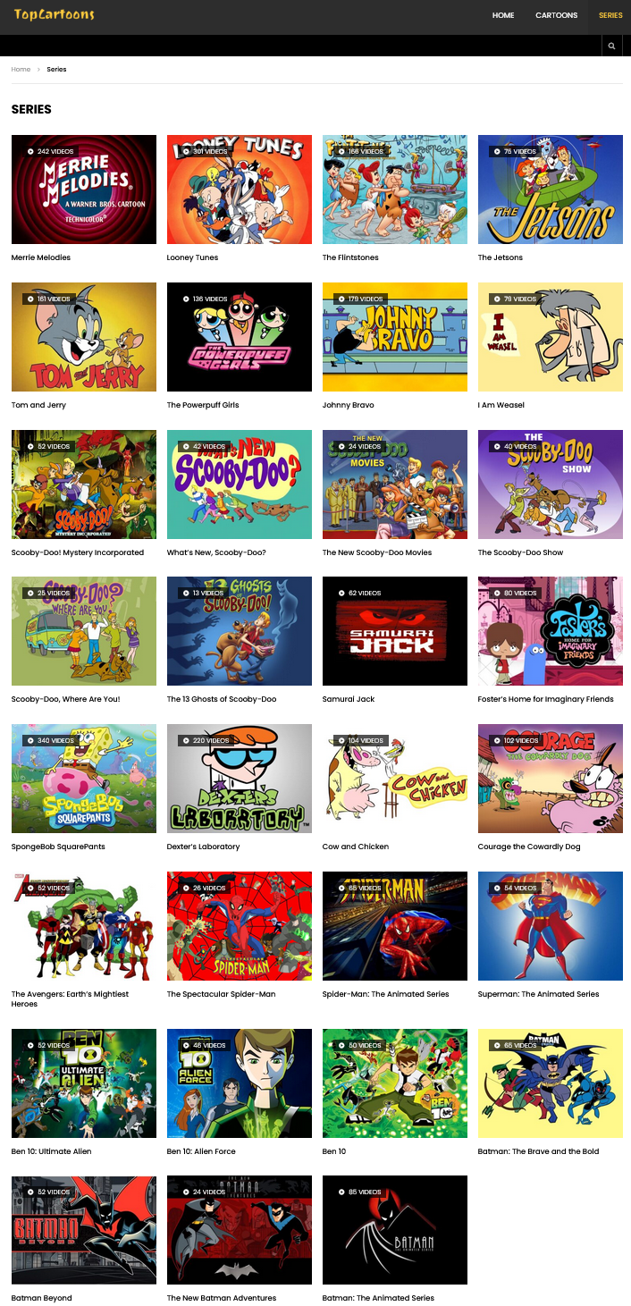

This website has most of the old retro to mid modern cartoons and best thing about this site is it is free of cost and perfectly secure without any unnecessary advertisements or blocks.Thats why it is on the first spot

**2. Youtube**



Youtube can be considered as top of its market in content with its colossal libraries of videos but it will get second spot as it is free but you cannot find every series or anime if there is present then it might be behind a paywall.But it one of the worlds best platform to watch high quality videos seamlessly.

**3. Crunchyroll**

https://www.crunchyroll.com/ 

This website is for hardcore animefans and is an official hub for streaming animes.

Only backdrop here is its behind a paywall with a very limited free and trial abilities.

If money is not the problem then this is a dream platform of a hardcore fan.

(RIP kissanime.ru)

**4. Openload.com/Flixtor.to**



Websites like these are most promptly not considered but what you can’t find anywhere that thing is present here,This place can be referred as black market zone and is definitely not safe and only be used via VPNS and other secured services. (pirate bay watching silently in corner)

**5. Cartoon networks**



Official site that contains all the series presented and licensed to cartoons networks ,This site contains numbers of short clips and moments for free and with a subscription can watch all the cartoons present on the site with Proper HD quality with multiple audio tracks and subtitles.

**6. Disney plus hotstar**



This website offers many of the series and movies licensed by disney including Marvel shows and movies with numerous cartoons and also discovery networks.

Disney plus offers a cheap price for its services considering other sites in this list.

Old shows like Doraemon,Kiteretsu etc can be streamed here.

These were some of the best websites that we can refer to when we have to watch and remember our old days.Some of the websites can be unsafe so if possible only official sources should be used and honor the creators of the respective series by supporting them.

Enjoying watching our old cartoon series is something that can help us rebound back into a state of happiness during these recessive times so I definitely recommend giving it a try yourself and reliving moments of your childhood and rejuvenate your mind once again.

Thanking you,

Aakarshit Srivastava